Water Bottle Rocket Design Contest

Calculation Exercises

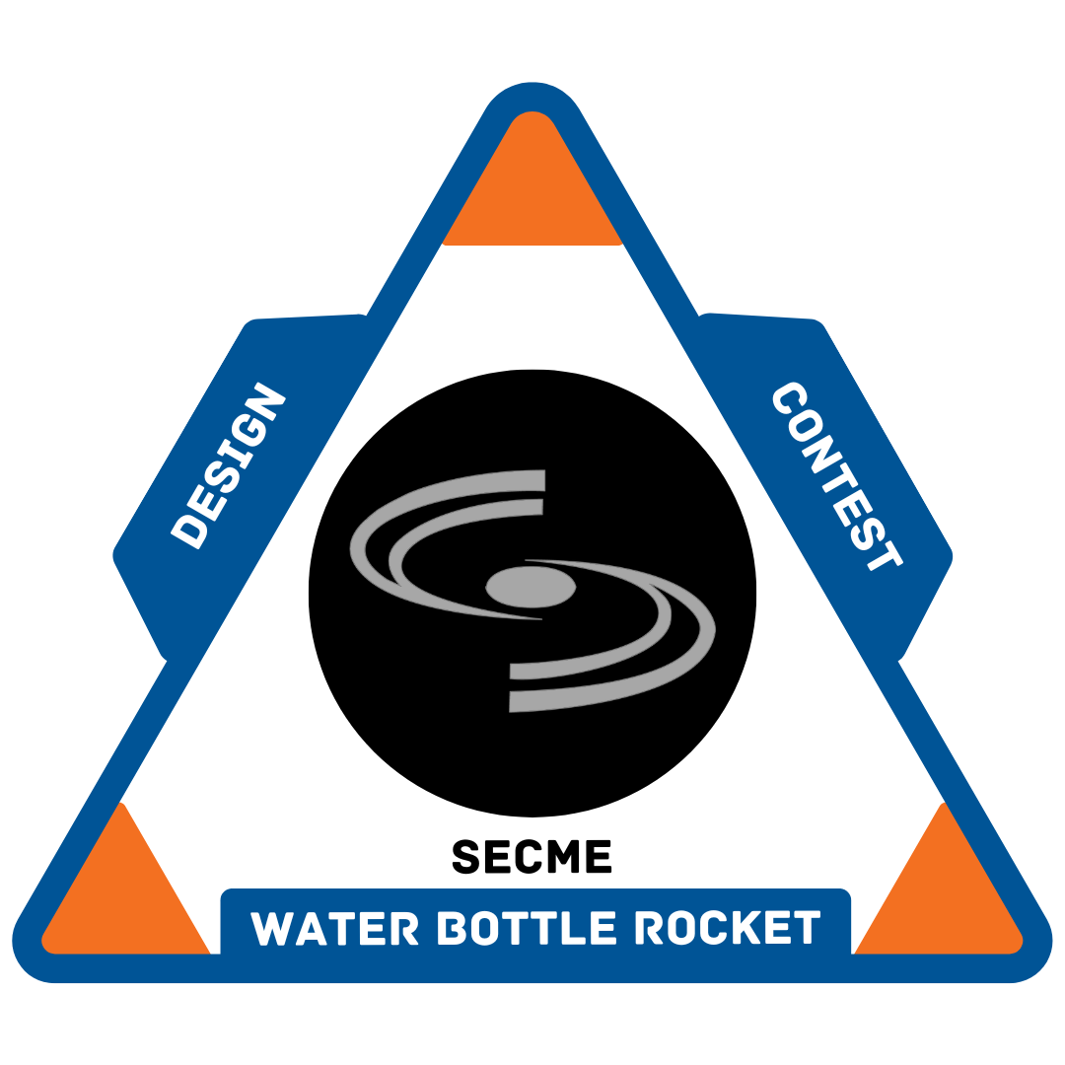

Elementary School Division

Pre-K – 2nd Grade

1. The Skywalker team constructed a water bottle rocket. They used the following materials. Complete the spelling of all the words by filling in the blank of the missing letters.

Decode the phrases:



Legend:



1. Which water bottle rocket below is the heaviest? Which rocket is the lightest?



Which is the **heaviest** rocket? Letter ____ Weight ____

Which is the **lightest** rocket? Letter ____ Weight ____

1. Which water bottle rocket is the tallest? Which rocket is the shortest?



Which is the **tallest** rocket? Letter ____ Height ____

Which is the **shortest** rocket? Letter ____ Height ____

**Question 4 Example:**

The **distance** around a circle is known as the **circumference.** The **diameter** is the **distance across the circle**, which goes through the circle's center.

The example below shows the circle circumference is **44 cm**, and the diameter is **14 cm**.



1. What is the circumference and diameter of the circle below?



Circumference = ____ cm

Diameter = ____ cm

**Question 5 Examples:**

A **triangle** is a shape that has three sides and three angles that add up to **180 degrees**. A **right triangle** is a type of triangle that has one angle that is **90 degrees**. The fins on the water bottle rockets are made of triangles. These fins help keep the rocket on track and stop it from spinning in the air.

Below are two right triangles with the bases and heights labeled. Notice that the height is the "up and down" measurement and that the base is the "across" measurement.

|  |  |
| --- | --- |
| **Example 1:** The height of the triangle below is **10 cm,** and the base is **6 cm**.   | **Example 2:** The base of the triangle is **4 cm,** and the height of the triangle is **7 cm**. |

1. What are the heights and the bases of the right triangular fins below?

Height = ____ cm Height = ____ cm

Base = ____ cm Base = ____ cm

1. The **hangtime** is the **amount of time** the water bottle rocket **stays in the air**.

The hangtimes of the three water bottle rockets A, B, and C are listed below. Rank the hangtimes from longest to shortest hangtime in first, second, and third place.



|  |  |  |  |
| --- | --- | --- | --- |
| Water Bottle Rocket | Hangtime | Weight | Height |
| A | 10 s | 98 lbs | 25 cm |
| B | 8 s | 15 lbs | 35 cm |
| C | 30 s | 43 lbs | 76 cm |

1st Place Longest Hangtime= ____ seconds, Rocket ____

2nd Place Middle Hangtime = ____ seconds, Rocket ____

3rd Place Shortest Hangtime = ____ seconds, Rocket ____

1. Circle the bar graph which illustrates the correct data for rockets A, B, and C shown in the data table below?



1. Rocket Weight



1. Rocket Height



1. Rocket Hangtime



1. Circle the countdown, which properly represents a countdown (numbers going from higher to lower)?

A. **5, 4, 3, 10, 1**

B. **5, 4, 3, 2, 1**

C. **5, 10, 15, 20, 25**

CALCULATION SHEET

CALCULATION SHEET

CALCULATION SHEET

CALCULATION SHEET